Iterator 遍历器
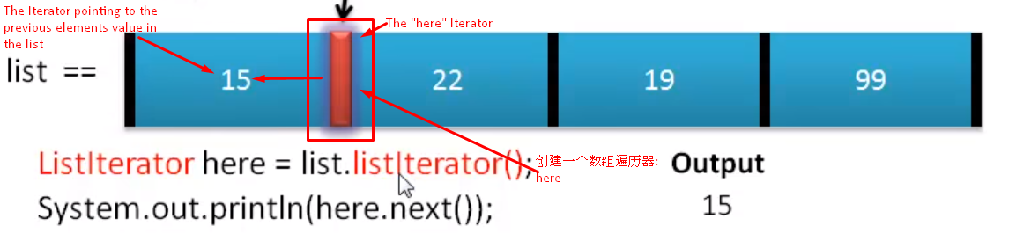

by default when the iterator is created ,it’s at the very left edge which not pointing to any value.

Difference between iterator and listIterator
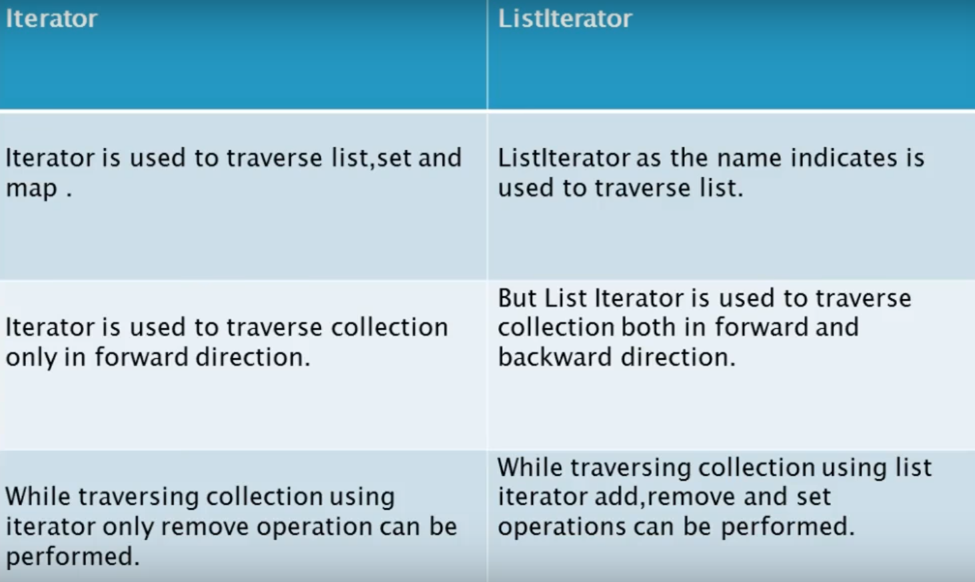

interface Iterator<T> methods:
.hasNext( ) :boolean
.next( ) :T
.remove( ) :void

interface ListIterator<T> extends(has all the method in Iterator) Iterator<T> methods:
.add(T item) :void
.hasPrevious( ) :boolean
.previous( ) :T
.set(T item) :void

Application - Word Frequency
interface Comparable method:
.comapreTo(T item) : int

Construct Iterator
自己构造iterator class遍历数组和用for loop遍历数组的好处在于不需要知道数组的长度

Bag abstract data type
a collection of bunch of object and method in unsorted order(like items in your bag)
only allows add new items into the bag
